OUR MISSION: We are called to proclaim the Gospel of Jesus through worship, witness, and ministry to our members and community.

Fifth Sunday of Easter
April 28, 2024

Welcome to St. James Evangelical Lutheran Church. If you are visiting and you have no church of your own, we invite you to make this your church home, but above all, we invite you to come and worship with us at any time. We worship every Sunday at 9:15 am. If you would like to speak directly to Pastor Randy, please call his cell.

Prelude

Announcements

Choir…………………………………………………………………..……….You Raise Me Up

Hymn ……..…………….…….……Christ Has Arisen, Alleluia (pgs. 12-13)

Greeting
P: In the name of the Father, and of the Son, and of the Holy Spirit. Amen.

Living Hope

P: Almighty God, you know us better than we know ourselves. You know our every sin, what we have done and what we have failed to do. We come to You with humble hearts, confessing our sin and seeking Your mercy.

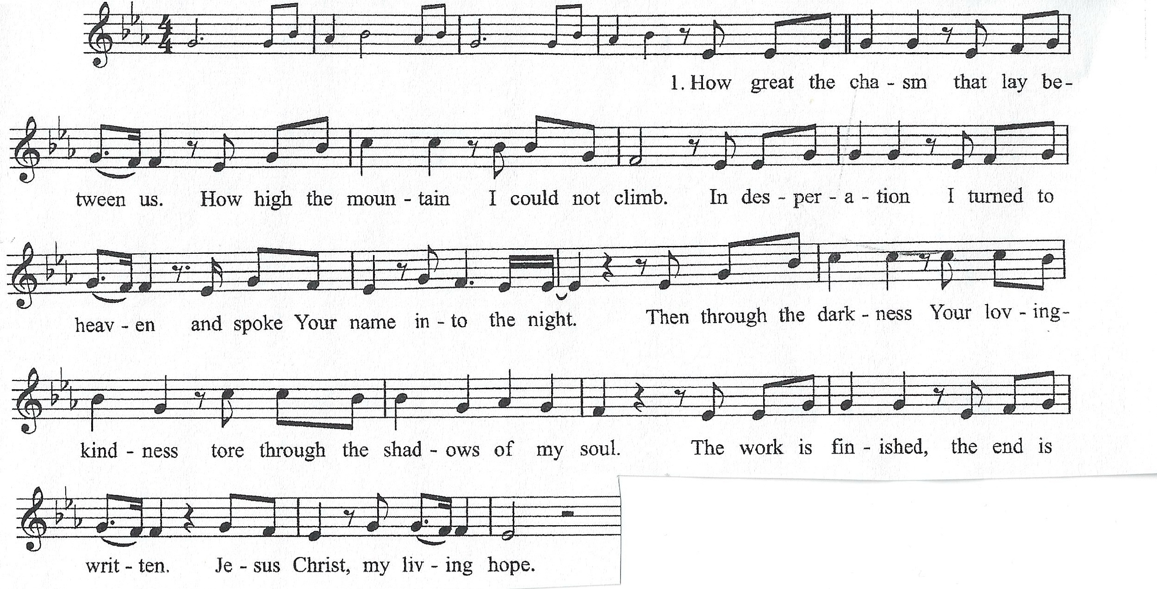
P: Let us take a moment of reflection to consider our Transgression.

P: Most merciful God, you have given your only Son to die for us. Have mercy on us, and for his sake grant us forgiveness.

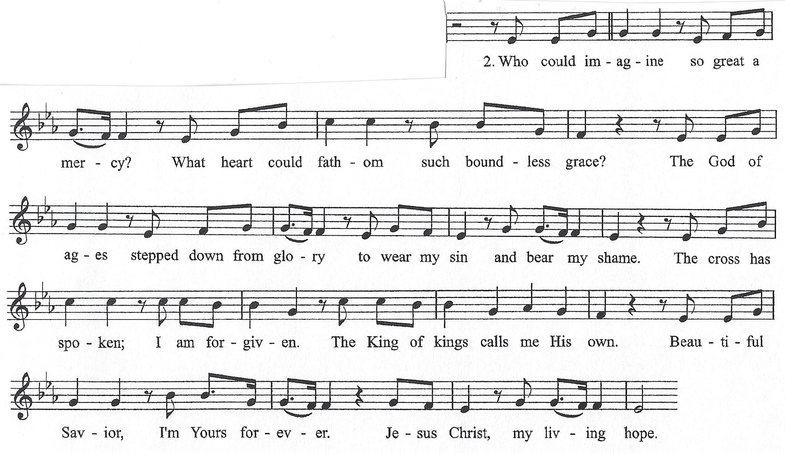

P: Almighty God, in his mercy, has given his Son to die for us and, for his sake, forgives us all our sins. As a called and ordained minister of the Church of Christ, by his authority, I therefore declare to you the entire forgiveness of all your sins!

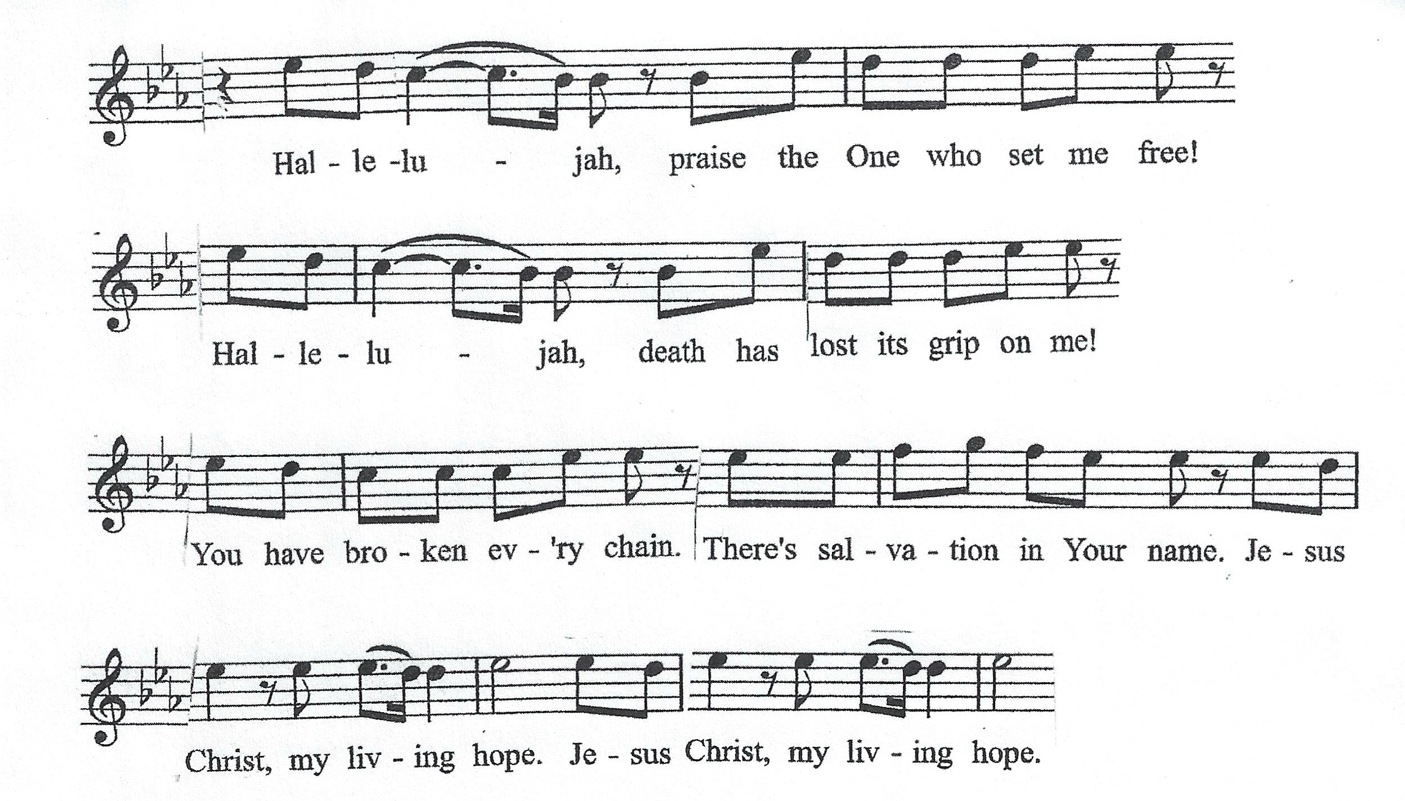(Repeat)

Apostles’ Creed
I believe in God, the Father almighty, creator of heaven and earth. I believe in Jesus Christ, his only Son, our Lord. He was conceived by the power of the Holy Spirit and born of the virgin Mary. He suffered under Pontius Pilate, was crucified, died, and was buried. He descended into hell. On the third day he rose again. He ascended into heaven, and is seated at the right hand of the Father. He will come again to judge the living and the dead. I believe in the Holy Spirit, the holy catholic Church, the communion of saints, the forgiveness of sins, the resurrection of the dead, and the life everlasting. Amen.

First Reading: Acts 8:26-40
²⁶An angel of the Lord said to Philip, “Rise and go toward the south to the road that goes down from Jerusalem to Gaza.” This is a desert place. ²⁷And he rose and went. And there was an Ethiopian, a eunuch, a court official of Candace, queen of the Ethiopians, who was in charge of all her treasure. He had come to Jerusalem to worship ²⁸and was returning, seated in his chariot, and he was reading the prophet Isaiah. ²⁹And the Spirit said to Philip, “Go over and join this chariot.” ³⁰So Philip ran to him and heard him reading Isaiah the prophet and asked, “Do you understand what you are reading?” ³¹And he said, “How can I, unless someone guides me?” And he invited Philip to come up and sit with him. ³²Now the passage of the Scripture that he was reading was this: “Like a sheep he was led to the slaughter and like a lamb before its shearer is silent, so he opens not his mouth. ³³In his humiliation justice was denied him. Who can describe his generation? For his life is taken away from the earth.” ³⁴And the eunuch said to Philip, “About whom, I ask you, does the prophet say this, about himself or about someone else?” ³⁵Then Philip opened his mouth, and beginning with this Scripture he told him the good news about Jesus. ³⁶And as they were going along the road they came to some water, and the eunuch said, “See, here is water! What prevents me from being baptized?” ³⁸And he commanded the chariot to stop, and they both went down into the water, Philip and the eunuch, and he baptized him. ³⁹And when they came up out of the water, the Spirit of the Lord carried Philip away, and the eunuch saw him no more, and went on his way rejoicing. ⁴⁰But Philip found himself at Azotus, and as he passed through he preached the gospel to all the towns until he came to Caesarea.

Psalm 150 (ESV)
¹Praise the Lord! Praise God in his sanctuary;
praise him in his mighty heavens!
²Praise him for his mighty deeds;
praise him according to his excellent greatness!
³Praise him with trumpet sound; praise him with lute and harp!
⁴Praise him with tambourine and dance;
praise him with strings and pipe!
⁵Praise him with sounding cymbals;
praise him with loud clashing cymbals!
⁶Let everything that has breath praise the Lord! Praise the Lord!

Second Reading: 1 John 4:1-11
¹Beloved, do not believe every spirit, but test the spirits to see whether they are from God, for many false prophets have gone out into the world. ²By this you know the Spirit of God: every spirit that confesses that Jesus Christ has come in the flesh is from God, ³and every spirit that does not confess Jesus is not from God. This is the spirit of the antichrist, which you heard was coming and now is in the world already. ⁴Little children, you are from God and have overcome them, for he who is in you is greater than he who is in the world. ⁵They are from the world; therefore they speak from the world, and the world listens to them. ⁶We are from God. Whoever knows God listens to us; whoever is not from God does not listen to us. By this we know the Spirit of truth and the spirit of error. ⁷Beloved, let us love one another, for love is from God, and whoever loves has been born of God and knows God. ⁸Anyone who does not love does not know God, because God is love. ⁹In this the love of God was made manifest among us, that God sent his only Son into the world, so that we might live through him. ¹⁰In this is love, not that we have loved God but that he loved us and sent his Son to be the propitiation for our sins. ¹¹Beloved, if God so loved us, we also ought to love one another.

Gospel Acclamation
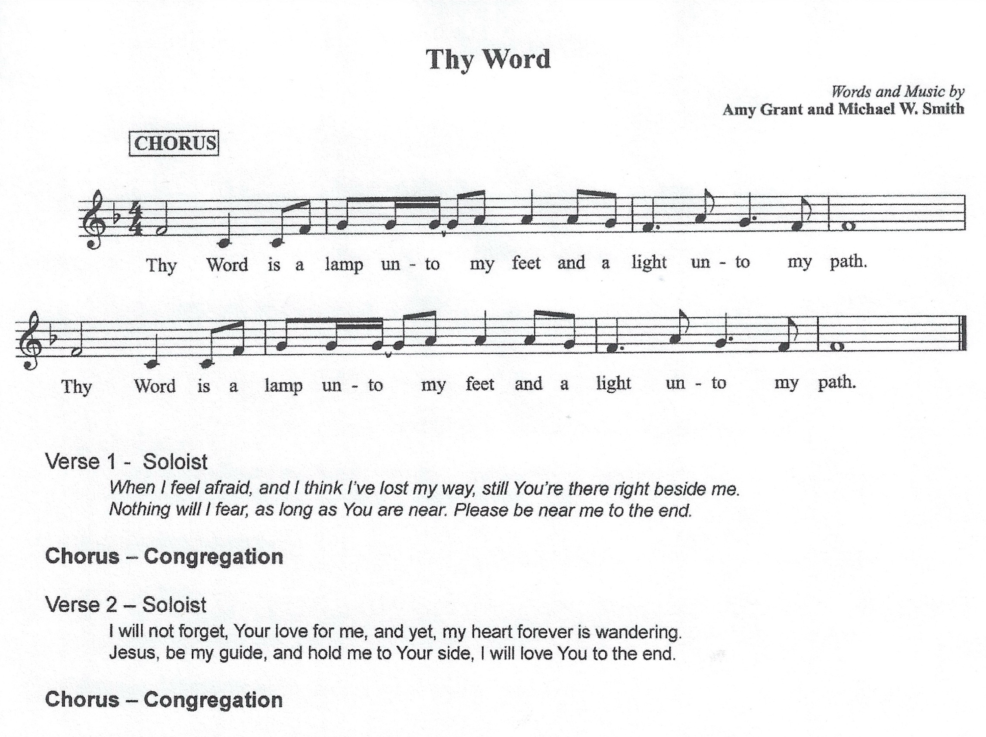

Gospel: John 15:1-8
¹{Jesus said,} “I am the true vine, and my Father is the vinedresser. ²Every branch in me that does not bear fruit he takes away, and every branch that does bear fruit he prunes, that it may bear more fruit. ³Already you are clean because of the word that I have spoken to you. ⁴Abide in me, and I in you. As the branch cannot bear fruit by itself, unless it abides in the vine, neither can you, unless you abide in me. ⁵I am the vine; you are the branches. Whoever abides in me and I in him, he it is that bears much fruit, for apart from me you can do nothing. ⁶If anyone does not abide in me he is thrown away like a branch and withers; and the branches are gathered, thrown into the fire, and burned. ⁷If you abide in me, and my words abide in you, ask whatever you wish, and it will be done for you. ⁸By this my Father is glorified, that you bear much fruit and so prove to be my disciples.”

Children’s Message

Sermon……………………………………………………………………..”Pruned Branch”

Hymn…….……………………………….……..……O Blessed Spring (page 14)

*Offering Song
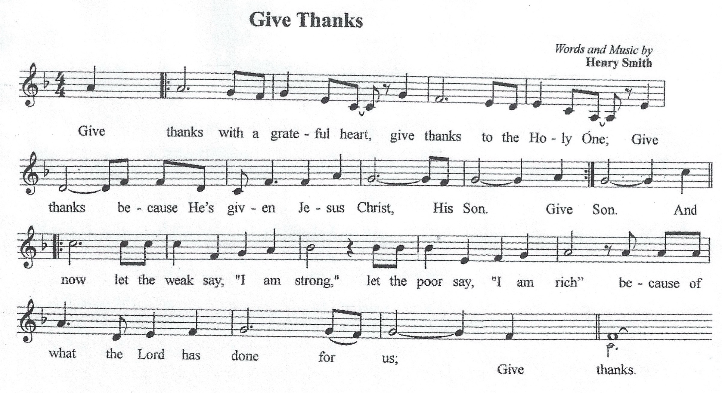
P: Holy God, we give you thanks for all that we have: ourselves, our time and our treasures, all that first belonged to you and has been gifted to us, your children. Accept our offerings as a sign of our devotion to you, and make us truly grateful for the many gifts we have received. In Jesus’ holy name we pray. C: Amen
Prayers of the church
Prayer Response:
P: Lord, in your mercy, C: Hear our prayer.

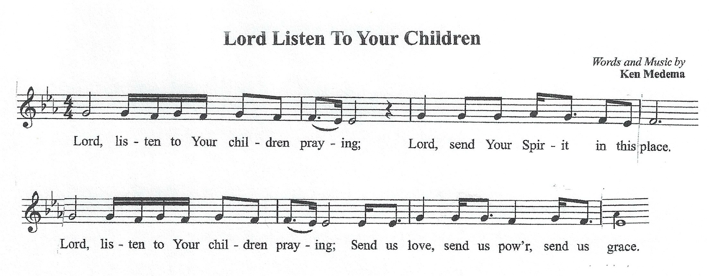

Lord’s Prayer
C: Our Father, who art in heaven, hallowed be Thy name, Thy kingdom come, Thy will be done, on earth as it is in heaven. Give us this day, our daily bread; and forgive us our trespasses, as we forgive those who trespass against us; and lead us not into temptation, but deliver us from evil. For Thine is the kingdom, and the power, and the glory, forever and ever. Amen.

Benediction

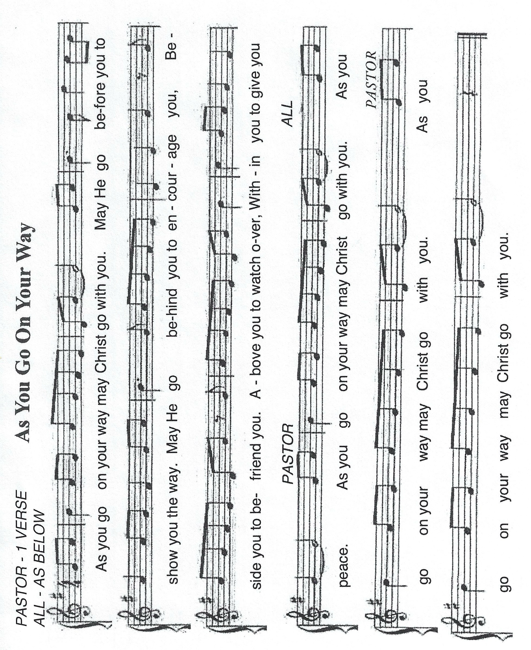

Hymn…………………….………….…………...Shine, Jesus, Shine (pages 15)

P: Go in peace. Serve the Lord. C: Thanks be to God!

Postlude

HYMNS
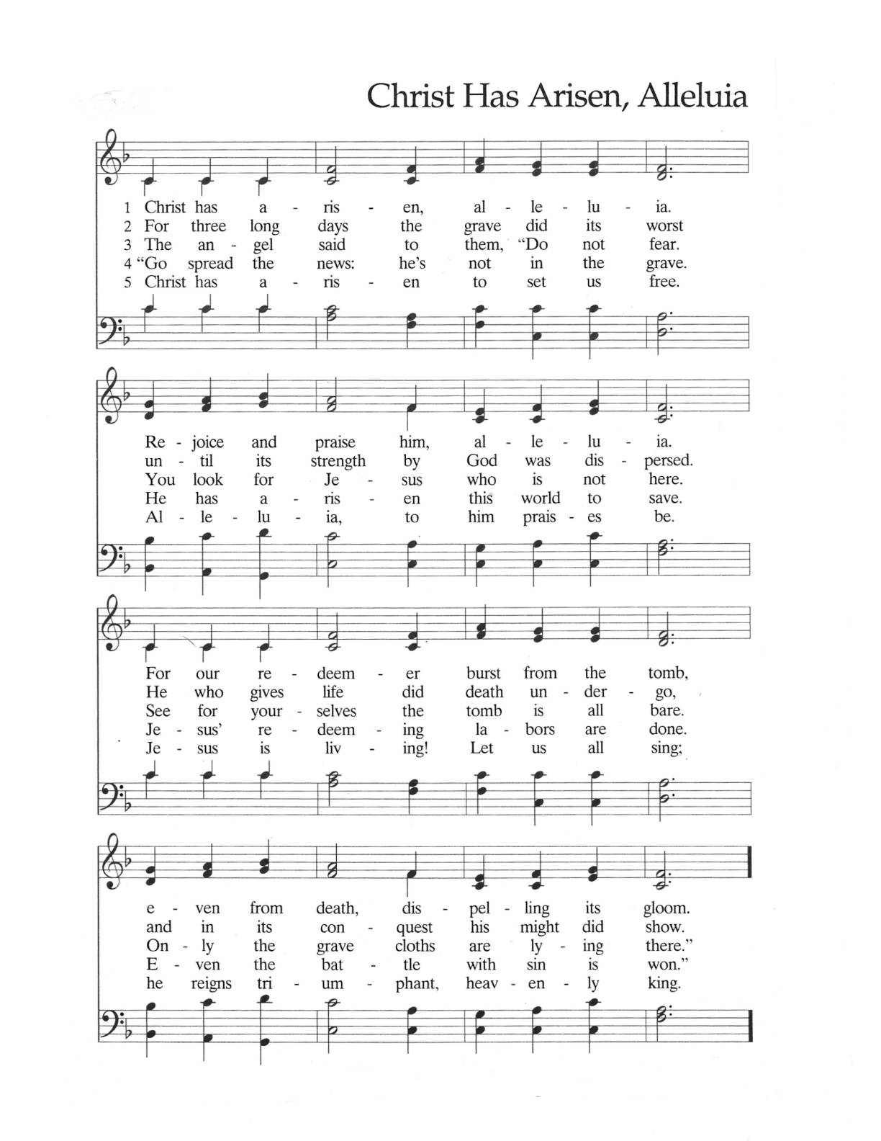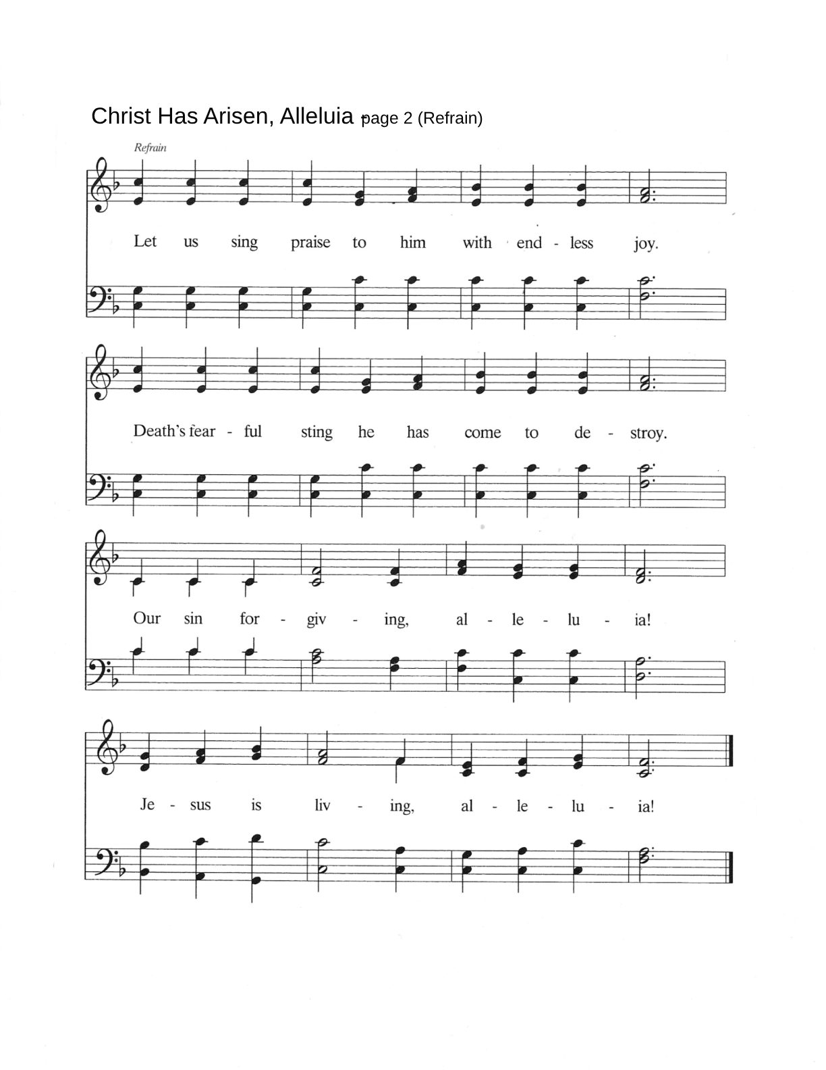
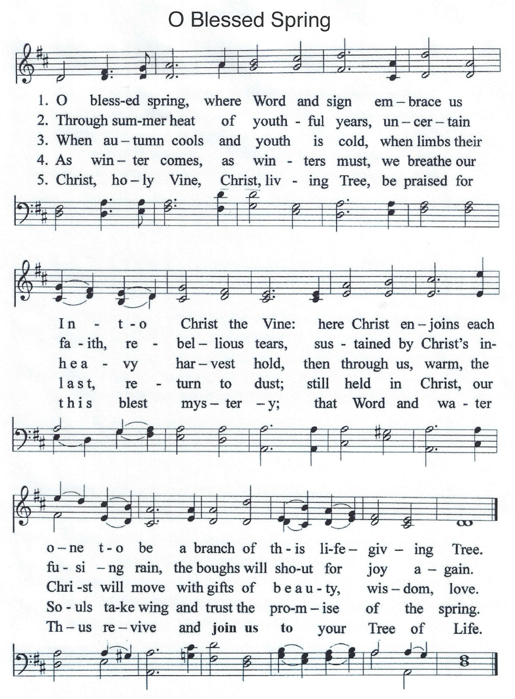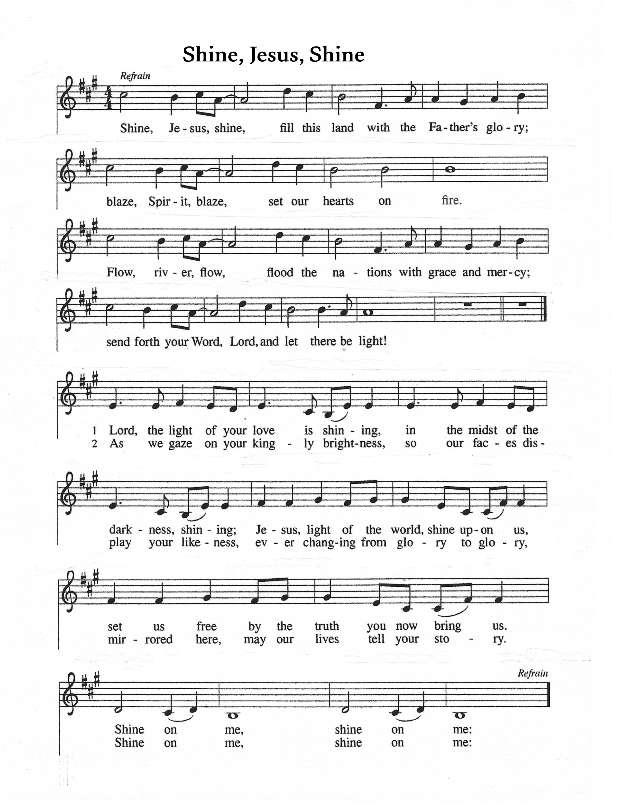
Let Us Remember in Our Prayers (*St. James Member)
*John Collins
*Bill Salisbury
*Dennis Schmidt
*Mark Voelker
*Joanne Witjes
*Roger Siegmann
*John Milleville
*Duane DeVantier
*Lewis Burgio
*Jan Voelker
*Marcia Gardiner
Barbara North
Cassie Stumpf
Norma O’Brien
Bob Foster
James Heath
Sabine Miskey
Mary Ann Richter
Beverly Boczon
Alfred Swift
Roger Myers
Greg Milleville
Denise Joy
Kate Hughey

Also Remember in Our Prayers
Those in nursing homes and shut-ins

*Morrie Johnson
*Elly Milleville
*Audrey Schmidli
*Glenn Schmidli
*Judy Brown

Organizations and Community
Stephen Ministry “Young Life”
Our area public and parochial schools

All Emergency Services personnel
*Scott Milleville *Michael Jon DeVantier David Nedell

The members of our armed forces
The men and women serving at the N.F. Air Base

Matthew Reddy (Niagara Falls)
Edmond Moloney (Virginia)
Eric Graca (South Korea)
Michael Coulter (Korea)
Joshua Drasgow (Korea)
Justin DeVantier (Niagara Falls)
Keith Coleman (Okinawa)

